Friends of Colliers Wood Parks and Green Spaces  Agenda  7:30pm Tuesday 2 November 2021 | 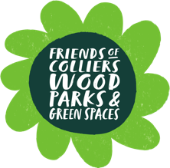

- Welcome
- Summary of Garden, River and Litter groups activity in September and October & upcoming calendar
- New project update
- 1st year anniversary & Mayor’s visit
- Social media & volunteer recruitment
- Any other business
- Date of next meeting: TBC Tuesday 4th or 11th Jan 2022. Zoom

A HUGE thank you to all volunteers across September and October…

Thanks to the Friends Committee of Margaret, Zoe, Helen, Bryony, Tom, Elizabeth, Maria plus the invaluable help from other local volunteers: Ken, Mence, Lesley, Yukiko, Chan, Jinni, Rob, Susan, Louise, Bergy, Brian, Richard, Sophie, Per, Andrew, Stuart, Kyle, Per, Peter, Mark, Claire, Kath, Abby and the Singleton Close team, Rhi, Karen, Dolma and Luza.

